E – Commerce Sales Analytics – Comparative Analysis of Amazon Flipkart Sales
Python (Google Colab) & Power BI Desktop

Amazon vs Flipkart – E-Commerce Sales & Customer Analytics
Project Summary:
- Analyse Amazon and Flipkart order, product, and customer rating data to compare platform performance, purchasing patterns, and the key factors driving revenue on each platform.
- Evaluate product category performance, payment method behaviour, and monthly sales trends to identify strengths and gaps between the two platforms.
- Develop an interactive Power BI dashboard that transforms cleaned sales data into visual insights, enabling platform-wise comparison and data-driven decision-making.
Tools And Technology Involved:

Area | Tools / Techniques
Data Handling | pandas, numpy
Visualization | matplotlib, seaborn
Environment | Google Colab (Python 3)
Techniques | Missing value imputation, category mapping, dataset merging, correlation analysis, EDA

Python (Google Colab):
Data Collection:
- Collected Amazon and Flipkart sales datasets containing order details, product category, quantity, unit price, total sales, payment method, delivery status, customer rating, and city/country — Amazon: 15,000 rows, 14 columns, Flipkart: 14,999 rows, 12 columns respectively.
- Validated and prepared the collected data by checking for missing values, duplicate records, and inconsistent data types before performing exploratory data analysis and building the Power BI dashboard.
Data Imputation:
- Categorical column imputation was accomplished using “Unknown” for missing values in Product Name, City, and Payment Method columns.
- Missing Product Category values were reconstructed using a Product Name → Category lookup map built from existing records.
- Flipkart's missing Quantity values were back-calculated using Total Sales ÷ Unit Price.
- Remaining missing Customer Rating values were filled using the overall average rating.
Data Manipulation:
- Column names were standardized across Amazon and Flipkart (e.g. Order_ID → order_id, Review_Rating → customer_rating) so both datasets could be merged on common fields.
- Both cleaned datasets were combined into a single Amazon_vs_Flipkart_Final.csv file, with a new “Platform” column added to distinguish each record's source.
- “Order Date” column was converted from Object to Date format, and a “Month” column was derived from it for trend analysis.
Visualization:
- Bar Chart (Total Sales Comparison) defines the revenue gap between platforms; it clearly emphasises that Amazon (~₹112 crore) slightly outperforms Flipkart (~₹106 crore) in overall sales.
- Pie Chart (Order Contribution by Platform) shows an even 50/50 split of orders, meaning both platforms handle a near-identical number of transactions.
- Scatter Plot (Quantity vs Total Sales) illustrates that total sales increase in clear steps as quantity rises from 1 to 5 units, though unit-price differences cause wide variation at every quantity level.
- Box Plot (Customer Rating Distribution) reveals that Flipkart customers report a higher and more consistent rating (median 4.0) compared to Amazon (median 3.0), indicating a stronger and more reliable customer experience on Flipkart.
- Horizontal Bar Chart (Top 10 Products by Sales) highlights Lipstick, Headphones, and Children's Book as the top revenue-generating products, with sales broad-based across Beauty, Electronics, and Lifestyle categories rather than one dominant item.
- Area Chart (Monthly Sales Trend) defines a fairly stable demand pattern, fluctuating narrowly between ₹17–19 crore per month with no strong seasonal spikes.
- Correlation Heatmap emphasises that Unit Price (0.73) drives Total Sales more strongly than Quantity (0.58), while Customer Rating shows almost no correlation with price, quantity, or sales value — confirming that rating is driven by service quality, not transaction size.

Power BI Desktop:
Import Cleaned Data in Power BI:
- The cleaned combined dataset (Amazon_vs_Flipkart_Final.csv) exported from Python was imported into Power BI Desktop.
- Data types were transformed — date columns and currency-related columns were set to appropriate formats — and a Platform slicer/filter was configured to enable dynamic, side-by-side comparison.
Interactive Dashboard — Combined View (No Filter):
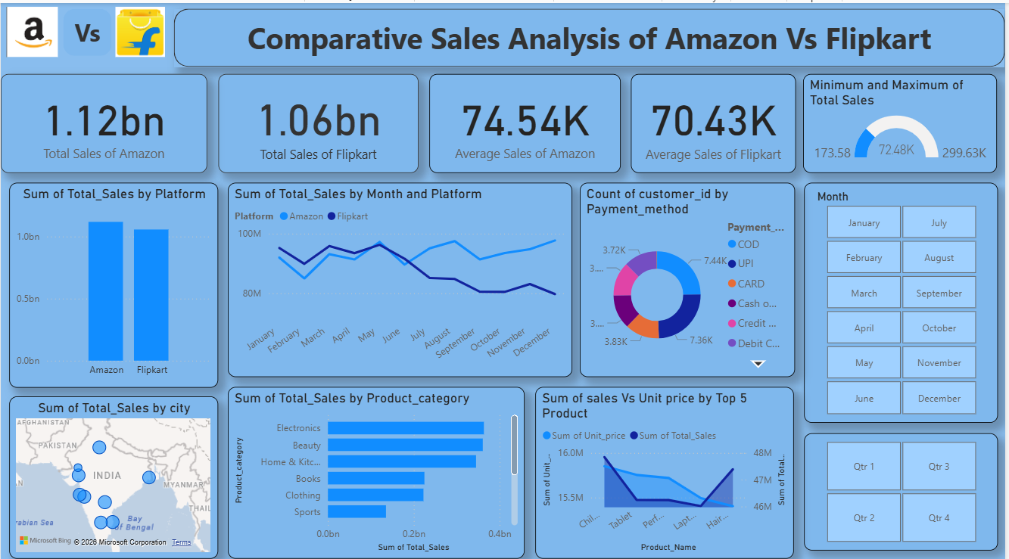

Insights from Dashboard — Combined View:
- Amazon totals ₹1.12bn in sales versus Flipkart's ₹1.06bn, with average order values of ₹74.54K and ₹70.43K respectively, meanwhile it emphasises Amazon's slight revenue edge despite matching order volumes.
- The monthly trend line shows Amazon consistently running above Flipkart for most of the year rather than the two simply trading places, indicating a persistent rather than occasional gap.
- Customer counts by payment method are fairly evenly spread across COD, UPI, Card, Cash on Delivery, Debit, and Credit — obviously it demonstrates no single payment preference dominating the combined customer base.
- Electronics leads as the top product category overall, followed by Beauty and Home & Kitchen, with Sports the smallest contributor.
Interactive Dashboard — Filtered to Amazon:

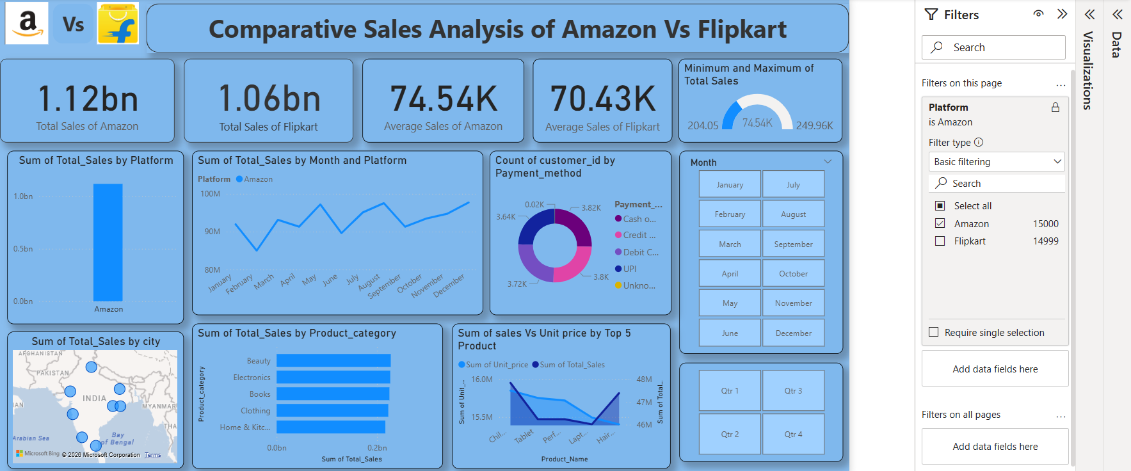

Insights from Dashboard — Amazon Filter:
- Amazon's monthly sales trend is volatile month-to-month, with peaks around March, June–July, and October, and dips in January–February and April, suggesting demand swings rather than a steady climb.
- Beauty ranks as Amazon's own top category, ahead of Electronics, Books, Clothing, and Home & Kitchen — a different order than the combined view suggested, showing Amazon's real category strength lies in Beauty.
- Amazon's top 5 products by sales are Children's Book, Tablet, Perfume, Laptop, and Hair Dryer — a lifestyle-and-electronics mix.
Interactive Dashboard — Filtered to Flipkart:
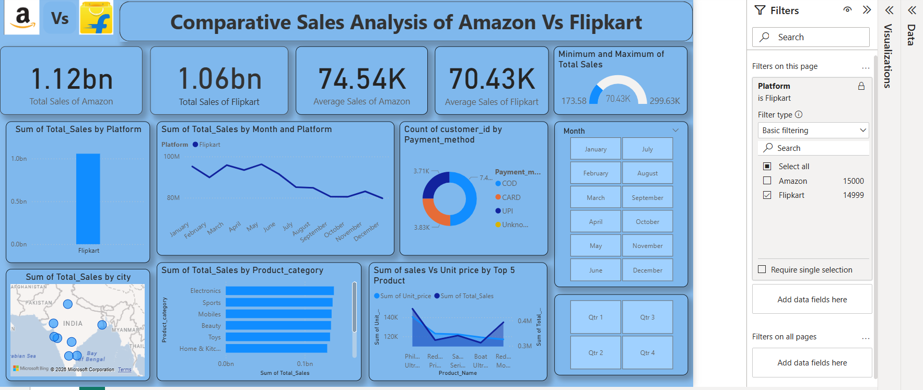

Insights from Dashboard — Flipkart Filter:
- Flipkart's monthly sales trend gradually declines from January (~95M) through to November/December (~80M) — a softer, downward drift, in clear contrast to Amazon's volatile-but-non-declining pattern.
- Flipkart's top categories are Electronics, Sports, and Mobiles, followed by Beauty, Toys, and Home & Kitchen — a notably different mix from Amazon, which carries no meaningful Mobiles or Toys presence.
- Flipkart's top 5 products by sales are branded electronics — Redmi, Samsung, Boat, Motorola, and similar devices — a sharp contrast to Amazon's lifestyle-oriented top sellers.
Final Summary & Business Recommendations:
- Amazon leads Flipkart in total revenue (~₹112 cr vs ~₹106 cr) despite an even 50/50 split in order volume, indicating Amazon customers skew toward higher-value purchases.
- Flipkart customers rate their experience higher and more consistently (median 4.0) than Amazon customers (median 3.0) — Amazon should investigate delivery, product quality, and refund friction to close this satisfaction gap.
- Unit price is the strongest driver of order value (correlation 0.73), more so than quantity purchased (0.58) — higher-priced catalogue items gradually boost platform revenue more than bulk-quantity promotions.
- Customer satisfaction shows almost no link to price or order size, suggesting opportunities to improve ratings should focus on service quality and delivery experience rather than pricing or discounting strategy.
- Amazon and Flipkart show different product strengths — Amazon skews Beauty/lifestyle while Flipkart skews branded Electronics/Mobiles — useful for platform-specific inventory and marketing focus.
- Quarterly/monthly trend analysis indicates stable, broad-based demand overall, with Amazon showing volatility and Flipkart showing a gradual decline through the year — worth monitoring for early intervention.
- Cities across India show spread-out demand for both platforms, making multi-city marketing and fulfilment investment more valuable than single-hub concentration.
Future Scope:
- Integrate Machine Learning models to predict future monthly sales, flag potential stock-outs, and detect anomalous or fraudulent transactions on both platforms.
- Enhance customer analytics by incorporating review text sentiment analysis alongside numeric ratings to better understand what is driving Amazon's lower, more inconsistent ratings.
- Use these insights to segment customers into groups (e.g. high-value, frequent buyers, low-rating/at-risk) and offer personalized recommendations, targeted marketing campaigns, and loyalty programs.
- Automate the Power BI dashboard to refresh from a live sales feed, enabling real-time platform-vs-platform monitoring instead of a static snapshot.

